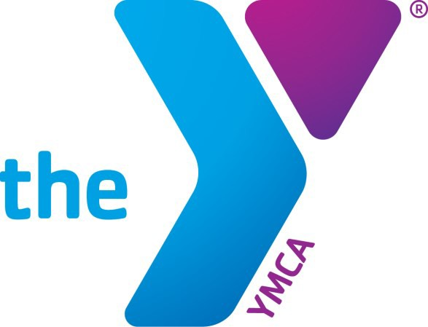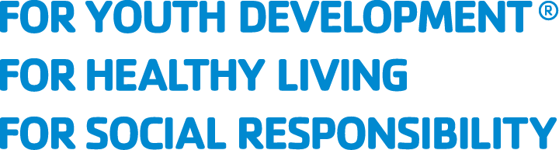

AFTER SCHOOL CARE
A PARENT’S HANDBOOK
WINONA FAMILY YMCA

Thank you for choosing the Winona Family YMCA’s after school care program! Our program is intended to be a place that allows children to learn, grow and thrive all the while meeting new friends and having fun. We’re looking forward to meeting your child/children soon and for another successful school year here in Winona!

Registration Process

Required Paperwork
In order to complete your registration, please ensure that the following have been submitted to the front desk:

- Student questionnaire submitted online during registration (emergency contact information, allergies, etc.)
- Immunization Records

- Payment Plan Form (all monthly participants)

- Credit or debit card information on file

Cancellation and Refund Policy
If the program doesn’t feel right for you and your child, the Winona Family YMCA requires a two-week written notice for all cancellations, emailed to the Youth Development Director. Upon cancellation, all scheduled payments past the two-week mark will be removed from your account, and care will stop being provided at the end of the two weeks. The YMCA will not provide refunds for cancellations made less than two weeks in advance.

Monthly Program Registration
Monthly Program Participants are registered for the entire school year. Payments are required on the 1st of each month. All participants must have a credit or debit card on file with payments scheduled by the first day of school.

Part Time Program Registration
Part Time Program Participants are registered for two-three days a week, based on the weeks they need care. Payment is required at the time of registration.

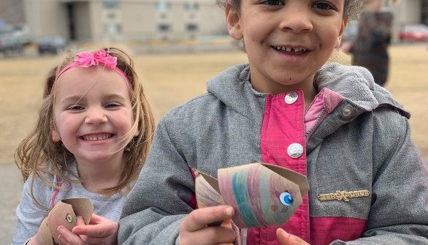

EXPECTED COMMUNICATION

Communication expectations from parents and YMCA staff

After Registration
After registration, be on the lookout for a confirmation email welcoming you to the After School Care program. In this email, the Director will identify any additional paperwork needed to complete your registration, as well as offer to answer any questions or concerns you have at that time.

During the School Year
During the school year, expect to receive periodic emails outlining activities, highlighting programs that are available for registration, and any other reminders or alerts that parents should be aware of.

From Parents
In order to ensure safety of all ASC participants, we ask that parents communicate with us in the following scenarios:
- Your child will be absent from ASC

- Your child is sick with COVID-19, scabies, impetigo, ringworm, head lice, chicken pox, or other infectious diseases

- Reported bullying, sexual or physical abuse, or general misconduct during After School Care hours from other program participants or YMCA staff

Mandated Reporters
Per Minnesota State Law, anyone who works with vulnerable populations is a mandated reporter and required by law to report any potential instances of physical, sexual, or emotional abuse to the county. All YMCA ASC staff are mandated reporters and will report any instances of abuse conveyed to them by program participants to Winona County Department of Human Services.

Pick up and Drop Off Expectations

All students must be signed in and out during drop off and pick up. Please ensure you always sign your child in and out of YMCA care.

We require identification at pick up by all authorized adults. When staff become familiar with you they may not ask for ID but please be prepared to show ID during pick up at all times. Additionally, if you have a different authorized adult picking up, please make sure they know to bring ID with them.

Attendance and Pick Up Changes
If your child is sick or will not be in attendance of our ASC program, please let us know by emailing the Director.

If a different adult will be picking up your child, please also let staff know by emailing or letting staff know at drop off.

Staff Handbook
If you’re interested in seeing the Staff Handbook, please request a copy from the School Age Director. The Staff Handbook has applicable policies and procedures for all ASC Staff to ensure safety or youth participants and success of the ASC program.

Behavior Policies and Expectations
The Winona Family YMCA After School Care Program has a Behavior Policy and Procedure. This includes tiered levels of behavior in the ASC programming.

Please be sure to familiarize yourself with the Behavior Policy and Procedures and to address any questions or concerns with the Director. The policies can be found on the website.

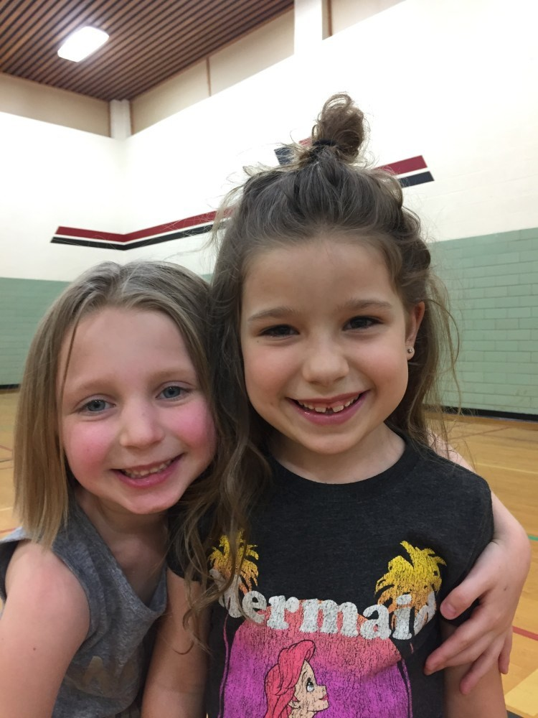
To ensure a successful year, we ask for clear communication from families regarding concerns about their child’s experiences. If you encounter an experience that you feel is inappropriate, please contact the Director immediately. If you ever have any suggestions, comments, or concerns, you’re also welcome to contact the Director. We’re constantly analyzing our programs to ensure growth, and welcome our parents to be active participants within that process.

SICK POLICY

Information pertaining to the ASC program’s sick policies and procedures

SICK POLICY

The YMCA does not provide care for students who are sick. If your child is sick, please alert YMCA staff and keep your child home from the ASC program.

In the event that your child becomes sick during ASC hours, parents will be alerted immediately and asked to pick up their child within an hour of the phone call. Your child will be removed from the group at this time and brought to a quiet and secure location where they can rest while they wait for pick up. Staff will remain nearby to assist the child if they need additional attention.

ADMINISTERING MEDICINE

Staff can administer medicine if requested by parents prior to the start of childcare. If your child requires daily or temporary dosages of any medicine, please contact the Director to fill out a Medicine Consent Form.

CONTAGIOUS ILLNESSES

The following illnesses warrant immediate action by the Director to ensure safety of other ASC participants. If your child is diagnosed with any of the following, please contact the Director as soon as possible.

- Impetigo

- Scabies

- Ringworm

- Chicken Pox

- Head lice

- COVID-19

When a child is diagnosed with any of the above illnesses, the child will be removed from the program immediately. If diagnosed with #1-4, students will not be allowed to return until cleared by a doctor as non-contagious. For head lice, participants will not be allowed to return until forty-eight hours after being treated for head lice, without instants of finding additional lice. When any of the above illnesses are detected, an email will be sent to all families and a notice posted at the site.

We recognize the inconvenience of not having childcare available, however we ask for adherence to these sick policies to ensure other program participants aren’t exposed to illnesses.

Please note that all lost and found clothing items will be removed from program sites once head lice has been found on a participant.

WEATHER AND OUTDOORS

GETTING OUTDOORS

LET’S EXPLORE OUTSIDE, YEAR-ROUND!
ASC sites utilize indoor AND outdoor programming year round. The YMCA hopes to instill an interest in the outdoors in all ASC participants through unstructured outdoor play time. Staff work to provide a safe and nurturing environment for children to play in, enabling all ASC participants to explore nature year-round and grow a deeper connection to the natural world. By doing so, we hope our program participants can learn to be more present and connected with one another and the world they live in.

SAFETY IN THE OUTDOORS
To ensure our students are safe outside, we require all participants to come prepared to be outside any day of the year. Please provide your child with the following items to ensure they can participate in all activities:

- A coat or jacket when temperatures are below 60 degrees

- Winter boots and snow pants when temperatures are below 40 degrees, or if there is snow on the ground.

- Hats and gloves when temperatures are below 40

- Sunscreen during No School Days in warmer months

- A hat, if desired, during warmer months

POLICIES OUTDOORS

RULES FOR PLAYING OUTSIDE
When it comes to rules for playing outside, we have very few. The reason for this is because we believe in encouraging students to play and explore in nature, and that using language like “be careful” can inhibit students from exploring to their full potential. That being said, we do have some basic rules that counselors enforce to ensure participant safety.

- No sticks or rocks

- No climbing trees, unless staff are spotting participants. Staff are properly trained on spotting techniques and do not allow children to climb above the counselor’s shoulder height

- Students are not allowed on the sidewalk at the parks and must play in designated areas, within eye sight of counselors

ADDITIONAL POLICIES
Additional policies and regulations will be established as needed and conveyed to program participants.

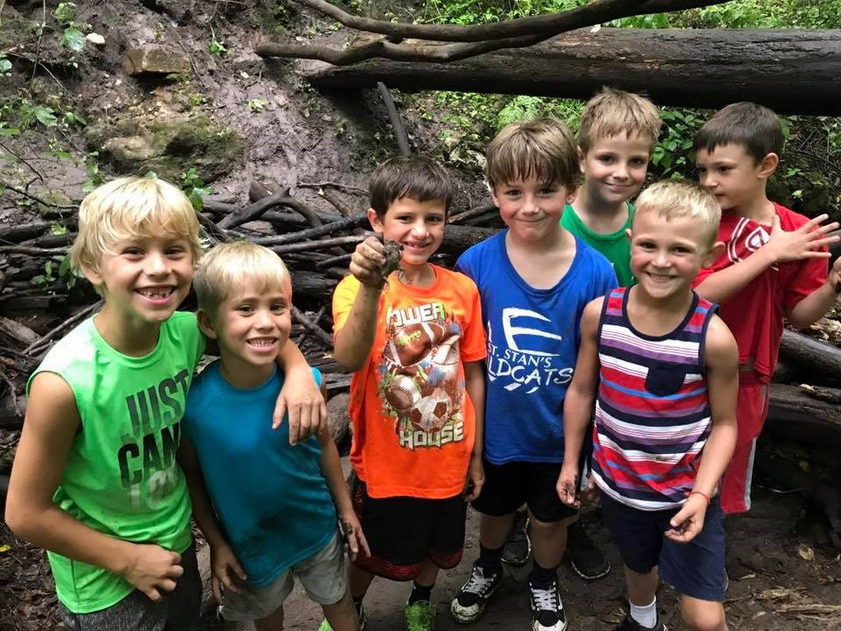

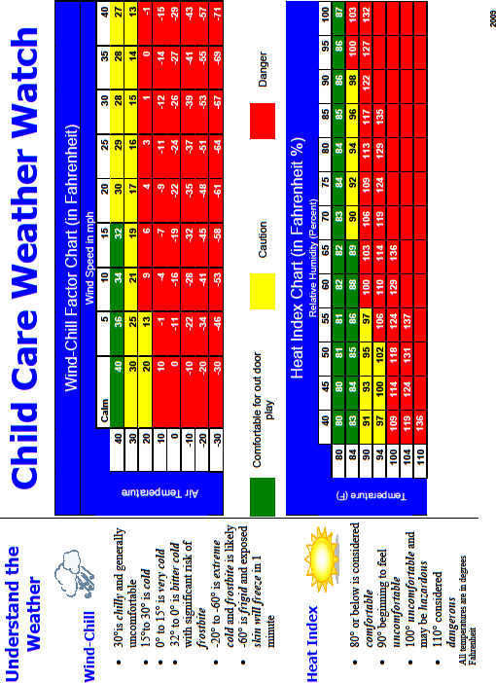

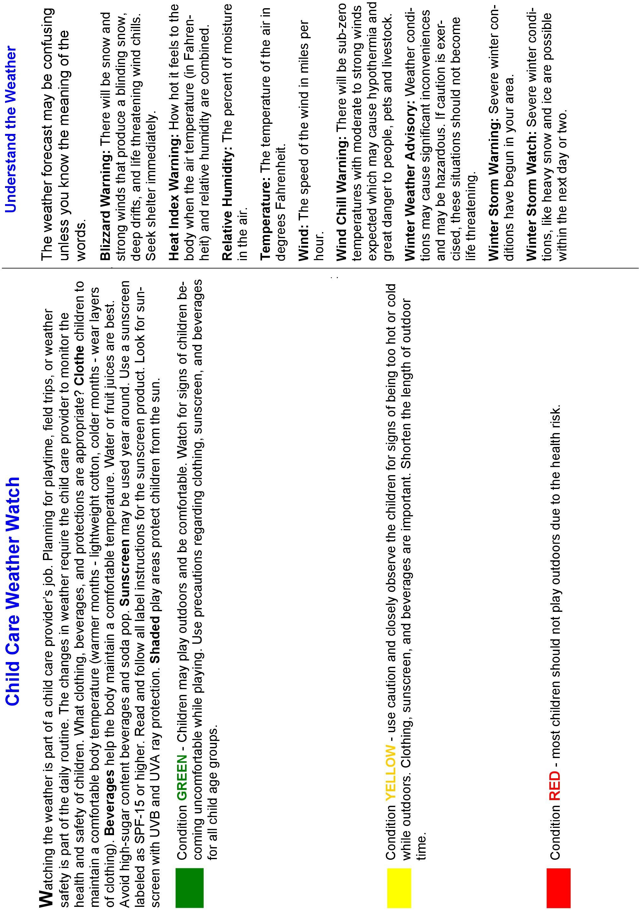

Additional Information

FINANCIAL AID AND COUNTY ASSISTANCE

FINANCIAL AID
The YMCA provides financial aid for those who qualify for memberships and programs. If you’re interested in learning more about the financial aid program, please contact Kristen Young at kyoung@winonaymca.org.

COUNTY ASSISTANCE
The YMCA is certified through Winona and Olmstead County for Childcare Assistance. If you are interested in learning more, please contact the county to see if you qualify. Those who qualify receive financial assistance for childcare, sent directly to the YMCA and applied to your monthly bill. Remaining balances are owed by program participants families.

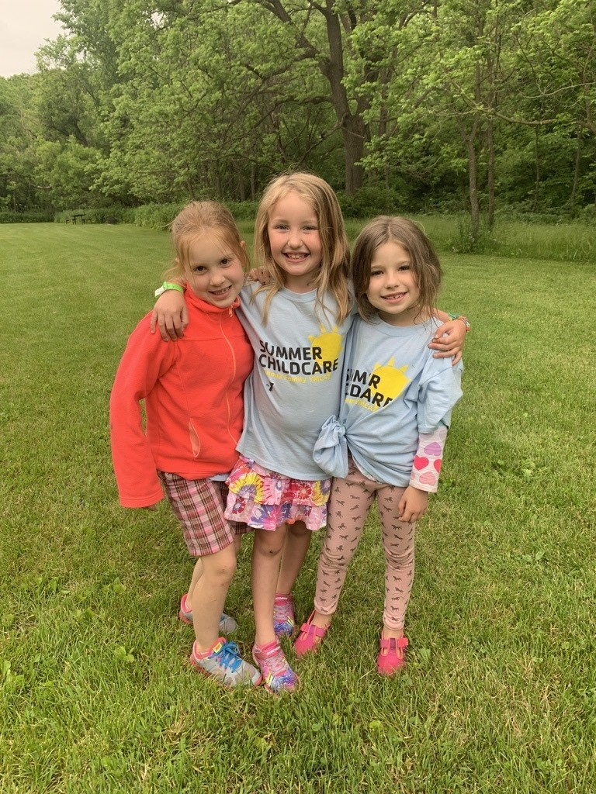

PROGRAM TRANSPORTATION AND FREE SWIM

TRANSPORTATION
Winona Area Public Schools provides free transportation from schools to designated sites. Please contact the school to arrange for transportation.

FREE SWIM
On Thursday our ‘Lowers’ (younger kids) have free swimming at the YMCA and on Fridays our ‘Uppers’ have free swimming at the YMCA. Please pack a bathing suit, towel, and plastic bag for wet items on these days.

CONTACT US
Brandy Walentiny, Youth Development Director
Email: bwalentiny@winonaymca.org
Phone: 507-454-1520 ext 104
111204 01/12

